MEETING TITLE: | City of Seguin – Cordova Rd Reconstruction  Lassig Farms Coordination |  | DATE: | 07/06/2023
PROJECT NUMBER: | 12775-00
Attendees: | PD: Steven Tate, John Tyler  Colliers: Wayne Flores  HDC-Group: Javier Alonso, Bryan Sims
AGENDA TOPICS:

Cordova Rd |  | All discussion items are subject to final CoS approval  Schedule:  - Design; Now through Q1 2024  - Pause for utility relocation and ROW  - Final plans/letting Q4 2025/Q1 2026  - Construction schedule pending  Scope  - Full reconstruction  - Expand from 2 to 4 lanes with raised median  - Dual shared use paths  - Minimum of 120’ ROW
Lassig Farms |  | Project Status  - Design and construction schedule- Concept plan is developed. Construction plans are on hold pending water supply. Lassig Farms team understands City of Seguin water improvements to be complete in 2026 and anticipate Unit 1 home construction to align closely.  - Platting, ROW dedication timeline, lot status  - Have a lot layout- to provide CAD files  - Dedicating 35’ from existing ROW, timeline not known for dedication  - Association with Lily Springs/Connection to SH 46  - Two connections to Lily Springs. One signalized intersection at SH 46  - TIA;  - Eastbound left turn warranted- Assumed delay until Unit 2- Proximity to ultimate SH 46 intersection may overlap  - Lassig Farms team voiced opposition to potential for right-in right-out driveway and requested plans.  - CoS approved sharing portion of schematic at development prior to finalization of 30% design. This layout is subject to change.  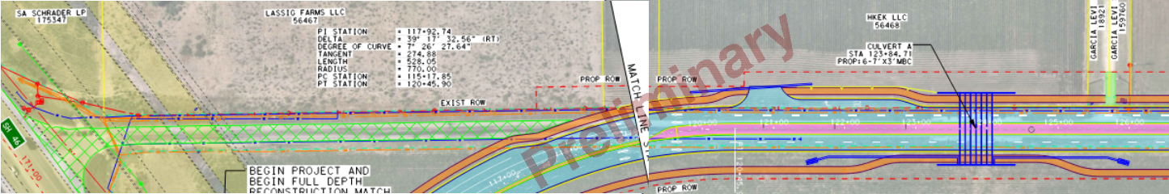  - West right turn is warrant- assumed delayed with Unit 2 or included with Cordova via developer agreement.  - Detention  - Linework needed  - Utilities  - Extension from Cordova corridor or Lily Springs?  - Along Cordova

